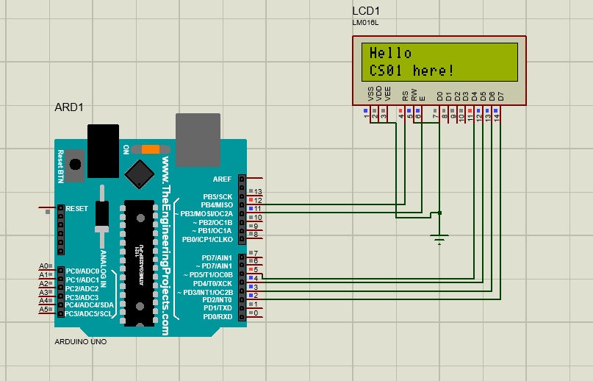
Experiment 6:

Source code:
#include <LiquidCrystal.h>
LiquidCrystal lcd(12, 11, 5, 4, 3, 2);
void setup()
{
lcd.begin(16, 2);
}
void loop()
{
lcd.clear();
lcd.setCursor(0,0);
lcd.print("Hello");
delay(1000);
lcd.setCursor(0,1);
lcd.print("CS01 here!");
delay(1000);
}

